Report
On
NSS Special Camp, 2023

NSS Unit of Sapatgram College organized a Special Camp in the adopted village Rabantari from 29th March to 4th April following the all criteria of NSS. Seventy volunteers in number participated in the programme. In the inaugural session Principal, Dr. Rajeshwar Prasad Singh, Vice-Principal, Mr. Mahabul Hoque Choudhury, RUSA Coordinator, Mr. Argeng Narzary, NSS Programe Officer, Mr. Saiful Sheikh, Gaonburah and villagers of Rabantari were present. Throughout the seven days of the camp various programmes were taken in to action as mentioned below-

- Survey on Youth not in Formal Education and Regular Employment
Volunteers approached on 30th March door to door to the household of Rabantari and filled up the form in detail, a prescribed format is given from Ministry of Youth Affairs and Sports, Government of India. Volunteers surveyed around fifty households and collect the data. Gaonburah of Rabantari Mr. Lajli Das helped over the journey of survey.
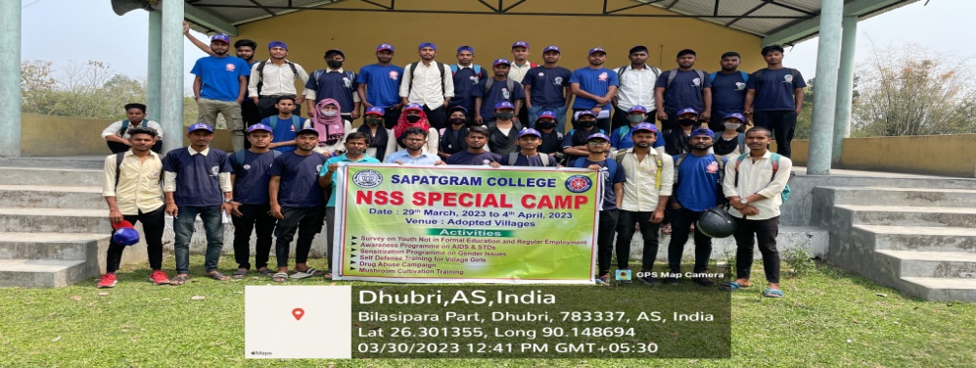

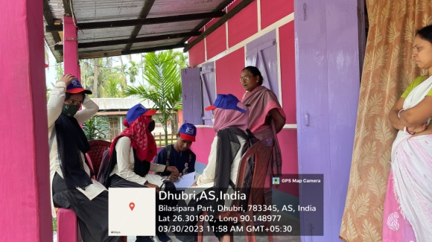
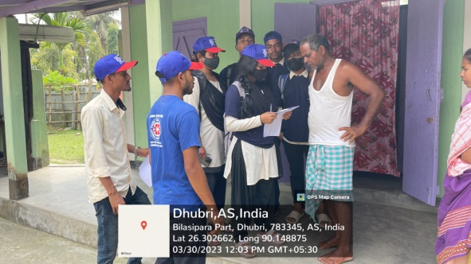

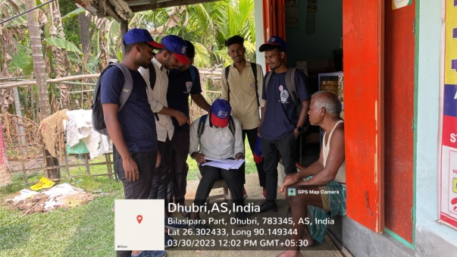
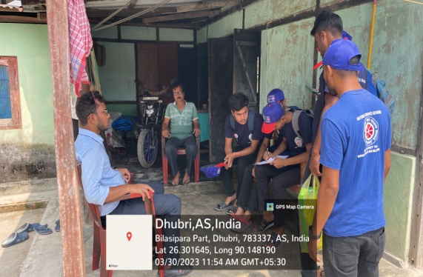

- Awareness Programme on AIDS and STDs

As a resource person Jayanta Kr. Nath, District Resource Person, State AIDS Control Society, Dhubri, Assam was invited, he delivered a detailed lecture on the causes and effects of AIDS and STDs. The programme was scheduled in the of Bhelakoba Pt 1at Baburam Barman ME School, Bhelakoba on 31st March 2023. The Headmaster of that school alongwith others teachers, villagers and NSS Volunteers were present.
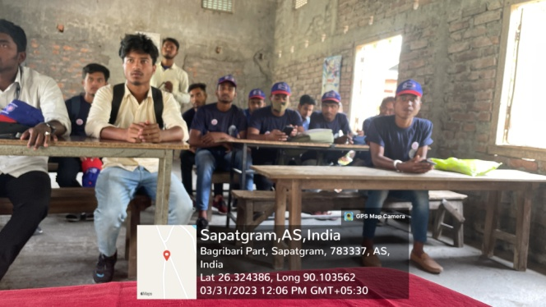
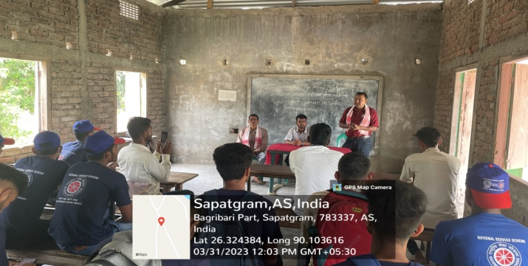

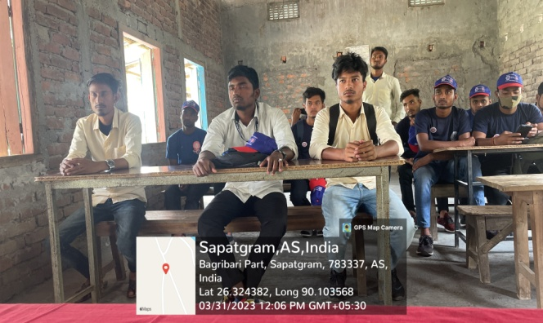
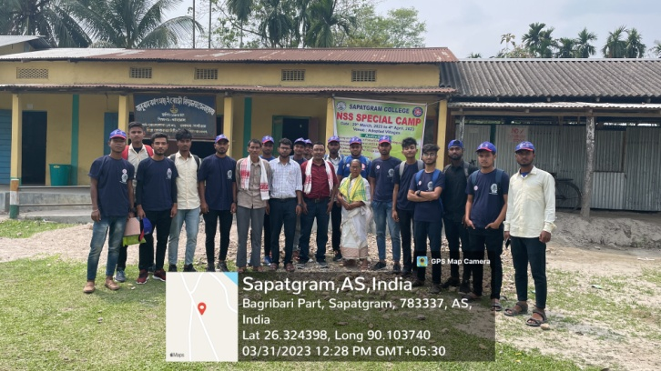

- Sensitization Programme on Gender Issues
For the programme of Gender Issues, a village named Kuthipara near Sapatgram Town was selected on 1st April 2023. In that village Dr. Juthika Das, Assistant Professor of Political Science, Sapatgram College as a resource person delivered a lecture, where she detailed various gender related issues in front of the villagers. Around 50 villagers gathered in the programme. Gaonburah of that village and other heads praised us for conducting such kind of programme in their village.

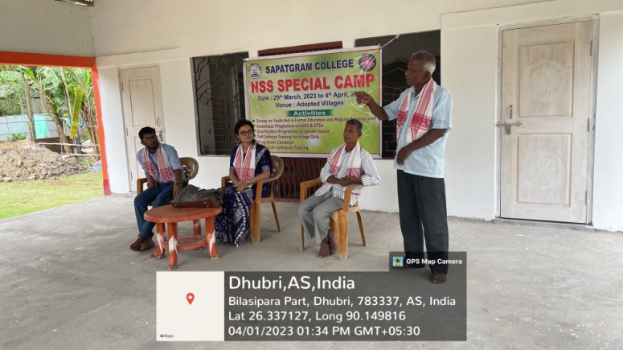

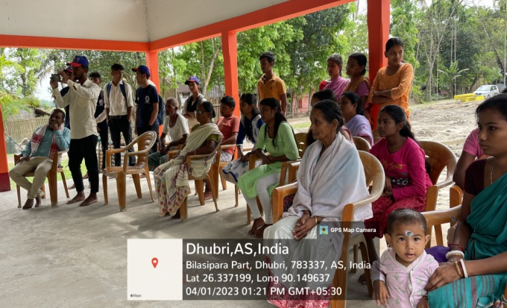
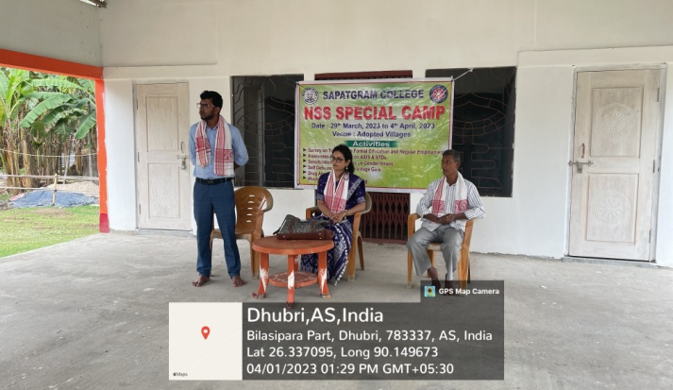

- Valedictory and Certificate Distribution Ceremony

Seven Days NSS Special Camp was ended with a valedictory session, in that session principal, vice-principal and other teachers were present. This session was organized on 12/04/2023. Various actions of activities were reflected through projector, certificates were awarded to the volunteers for their active participation. The programme was ended with vote of thanks.

