REPORT
ON
ONE WEEK PAINTING FESTIVAL-2022
&
TREE PLANTATION DRIVE

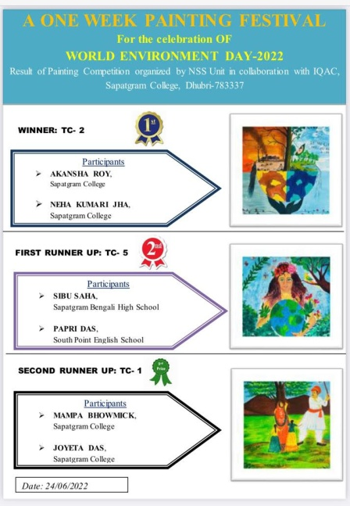
On the occasion of “World Environment Day” NSS unit in collaboration with IQAC of Sapatgram College on 5th June 2022 has organized two programmes simultaneously. One is ‘Tree Plantation Drive’ which was started at 9:00 am following by this, a lecture session was arranged on Environment Awareness. Principal, Dr. Rajeshwar Prasad Singh delivered a valuable lecture on preserving and conserving the sustainable environment. Another programme was the inauguration of “One Week Painting Festival” (5th June-11th June 2022). The chief guest of the programme was Mrs. Minati Sarkar, Painter and Social Activist. After the plantation of the saplings in many places of the campus a wall painting competition was started, around hundred participants were participated. The instructor of the programme was Mr. Gautam Paul, a renowned painter of Sapatgram. Various ecological paintings were painted. Result of the competition was declared according to the merits of artists who participated from the various nearby schools. Money Prize and Certificate have been provided
to the winners, (Winner-500, 1st Runner Up-300, 2nd Runner
Up-200) and everyone got certificate of participation.

Winner: 1. Akansha Roy, Sapatgram College
2. Neha Kumari Jha, Sapatgram College

First Runner Up: 1. Sibu Saha, Sapatgram Bengali High School
2. Papri Das, South Point English School

Second Runner Up: 1. Mampa Bhowmick, Sapatgram College
2. Joyeta Das, Sapatgram College

IQAC coordinator, Dr. Habib Fazlul Basid and NSS Programme officer Mr. Saiful Sheikh guided the participants in the programme.

Some following snapshots of the programme have been attached under

