Report of Essay Writing competition 8/3/2022
Department of Education, Sapatgram College had organized an Essay writing Competition on the occasion of International Women’s Day on ‘Social Contribution of Dr. Birubala Rabha’ on 8/3/2022. The pragramme was inaugurated by Dr. Rajeshwar Prasad Singh, Principal of the College. The pragramme was convened by Mrs Trishna Bhuyan. Dr. Munmun Bannerjee HoD of Education was introduced the Resource persons among the participants, welcoming the guest and participants.The entire pragramme was Resourced by Mrs.Minati Sarkar Madam, Ex chairman of Sapatgram municipality and Aprna Sengupta Madam, EX Vice Principal of Sapatgram College.The Resource person very clearly, indepthly and widely explained about the status of women from ancient to present Society. Many participants were participated at the competition. After completion of the speech of the resource persons, prize was distributed among the winners. And the pragramme was concluded by vote of thanks of Mrs. Smrtirekha Barman, Convener, Women Cell Sapatgram College. Some snapshots of the pragramme was attached herewith-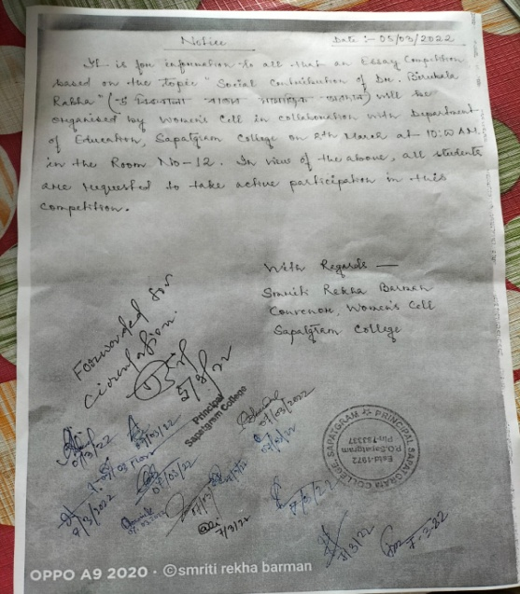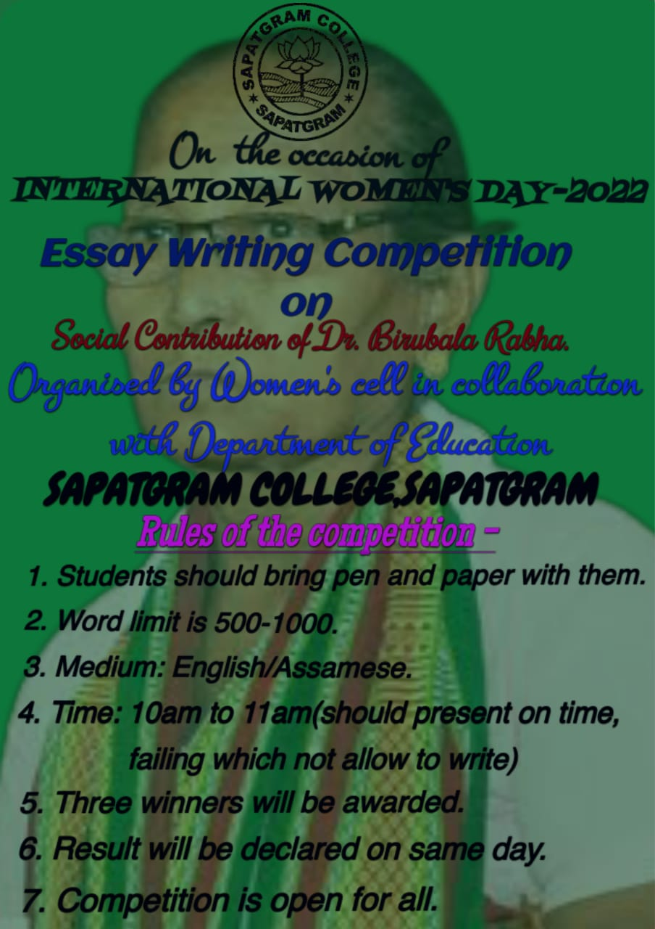
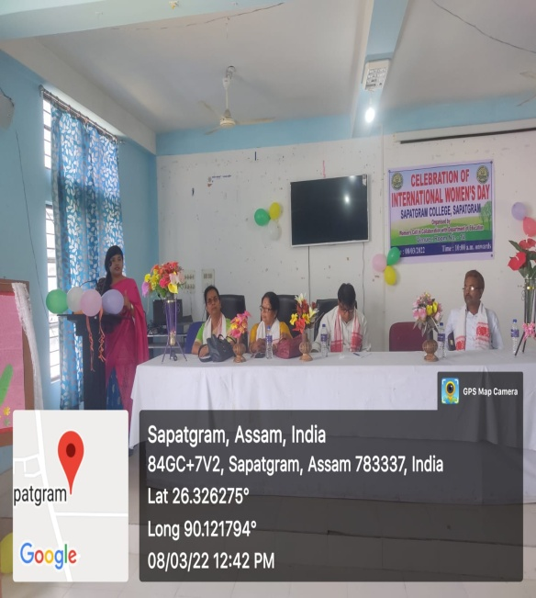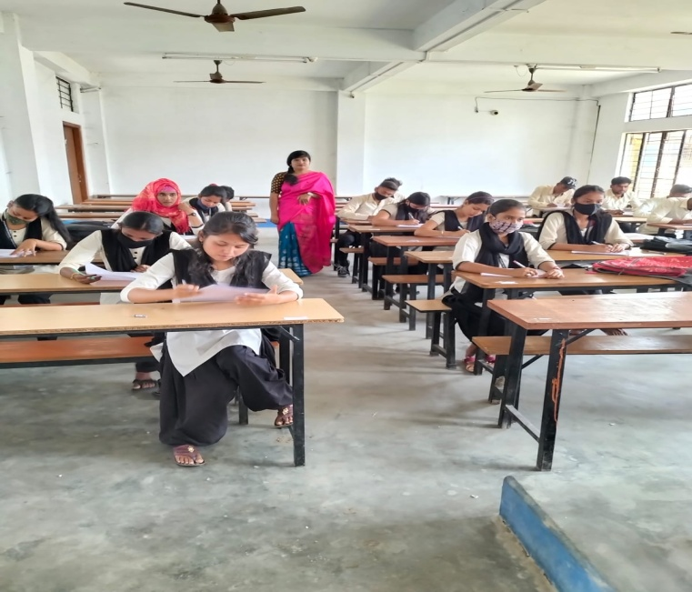
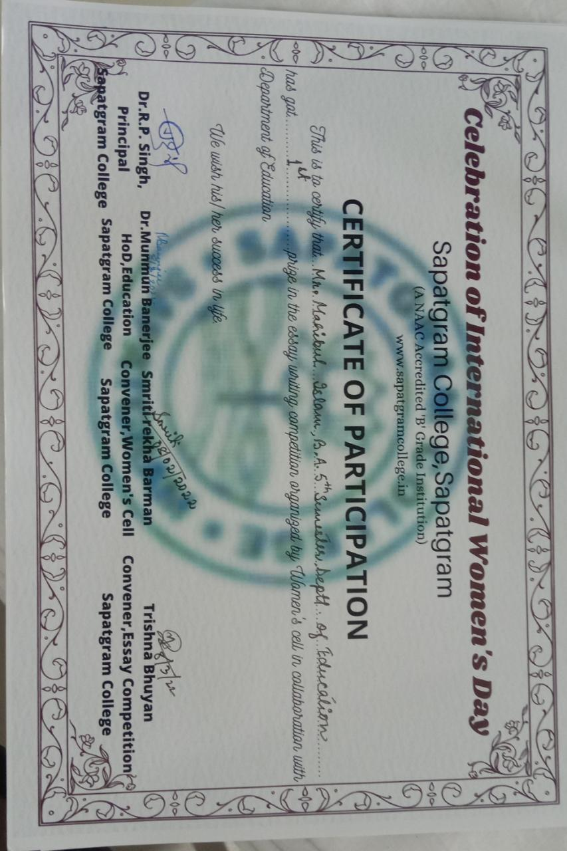1